**Floyd Warshall**

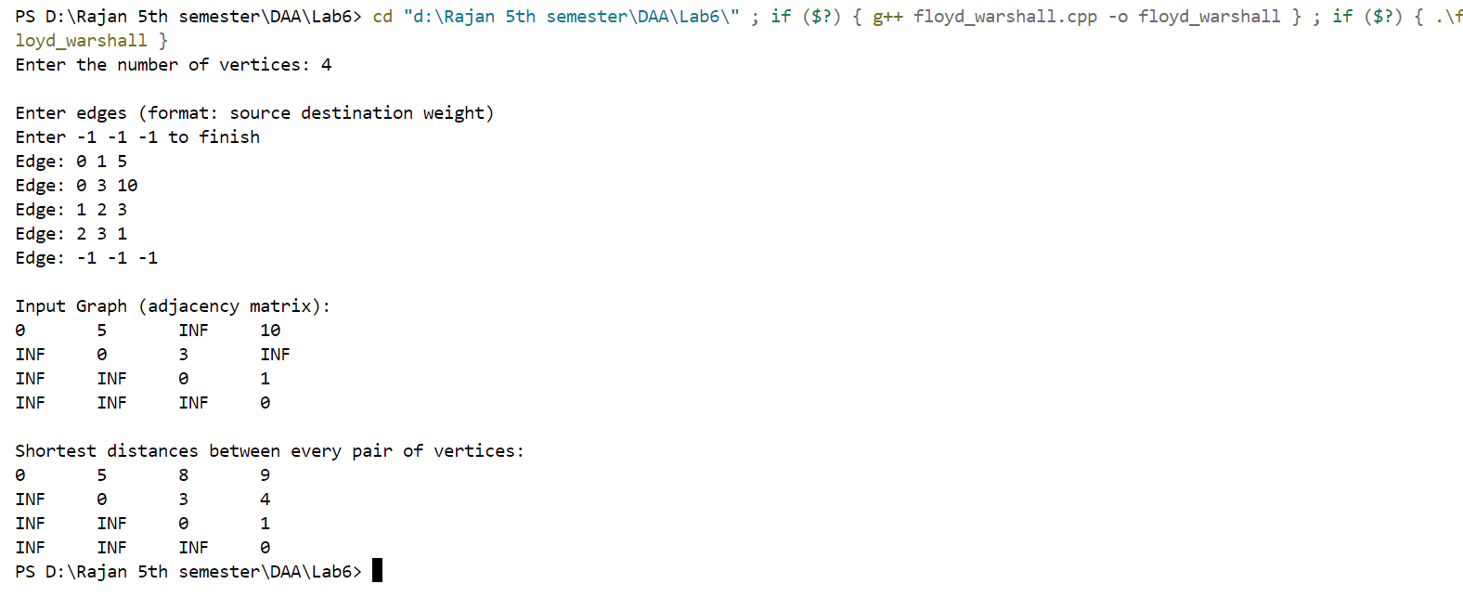

**Travelling Salesman**

